 **DIRECT DEBIT**

Make Life Easier

|  |  |  |  |  |  |  |  |  |  |  |  |  |  |  |  |  |  |  |  |  |  |  |  |  |  |  |  |
| --- | --- | --- | --- | --- | --- | --- | --- | --- | --- | --- | --- | --- | --- | --- | --- | --- | --- | --- | --- | --- | --- | --- | --- | --- | --- | --- | --- |
| Direct Debit is the easiest way to pay your bills. It is quick and easy, and avoids having to wait in queues or remember to post payments on time. | | | | | | | | | | | | | | | | | | | | | | | | | | | |
| Unlike a banker’s standing order, your instruction does not have to be renewed each year. We tell you in advance of the amounts and dates of the payments. | | | | | | | | | | | | | | | | | | | | | | | | | | | |
| Direct Debit payers have a choice of payment dates; you can pay monthly on any day of the month, **except 29, 30 and 31**. **Please enter your preferred date in the box below**. | | | | | | | | | | | | | | | | | | | | | | | | | | | |
| Please complete the form below and send it to:  **Leasehold Team, London Borough of Hillingdon,**  **2N/09, Civic Centre, High Street, Uxbridge, UB8 1UW**  **Please remember to enter your name and address on the other side of the slip.** | | | | | | | | | | | | | | | | | | | | | | | | | | | |
| This guarantee should be detached and retained by the Payer.  The Direct Debit Guarantee | | | | | | | | | | | | | | | | | | | |  | | | | | | | |
| * This Guarantee is offered by all banks and building societies that accept instructions to pay Direct Debits. * If there are any changes to the amount, date or frequency of your Direct Debit London Borough of Hillingdon (LBH) will notify you 10 working days in advance of your account being debited or as otherwise agreed. If you request LBH to collect a payment, confirmation of the amount and date will be given to you at the time of the request * If an error is made in the payment of your Direct Debit by LBH or your bank or building society you are entitled to a full and immediate refund of the amount paid from your bank or building society. * If you receive a refund you are not entitled to, you must pay it back when LBH asks you to * You can cancel a Direct Debit at any time by simply contacting your bank or building society. Written confirmation may be required. Please also notify us at the address above or email * [**leasehold@hillingdon.gov.uk**](mailto:leasehold@hillingdon.gov.uk) | | | | | | | | | | | | | | | | | | | | | | | | | | | |
| ================================================================================================= | | | | | | | | | | | | | | | | | | | | | | | | | | | |
|  | | | | **Instruction to your Bank or Building Society to pay Direct Debit** | | | | | | | | | | | | | | | |  | | | | | | | |
| Please fill in the form and send to: Leasehold Team,  London Borough of Hillingdon,  2N/09, Civic Centre, High Street, Uxbridge, UB8 1UW | | | | | | | | |  |  | | | | Originator’s Identification number | | | | | | | | | | | |  | |
| **9** | | **2** | | **2** | | **6** | | **4** | | **7** | |
| To: The Manager | | | | Bank / Building Society | | | | |  | | | | | For London Borough of Hillingdon use only | | | | | | | | | | | | | |
|  | | | | | | | | |  | | |  | |  |  | |  | |  | |  | |  | |  |  | |
| Address: | | | | | | | | |  | | |  | |  | | | | | |  | | | | | |  | |
|  | | | This is not part of the instruction to your bank or building society | | | | | | | | | | | | | | | |
| Post Code: | | | | | | | | |  | | |  | **MONTHLY** **INSTALMENTS** Enter preferred date (**NOT** 29/30/31) | | | | | | | | | | | | | |  |
| Name(s) of account holder(s): | | | | | | | | |  | | | | I wish to pay in full **ONCE A YEAR in Sept** (please tick) **Service charge only** | | | | | | | | | | | | | |  |
|  | | | | | | | | |  | | | | I wish to pay by **2 INSTALMENTS** - Sept & Jan - (please tick) **Service charge only** | | | | | | | | | | | | | |  |
| Bank / Building Society account number: | | | | | | | | |  | | | Please pay London Borough of Hillingdon Direct Debits from the account detailed in this Instruction subject to the safeguards assured by the Direct Debit Guarantee. I understand that this Instruction may remain with London  Borough of Hillingdon and if so, details will be passed  electronically to my Bank / Building Society. | | | | | | | | | | | | | | | |
|  |  |  |  | |  |  |  |  |  | | |
| Branch Sort Code: | | | | | | | | |  | | Signature: | | | | | | | | | | | | | | | | |
|  |  |  |  | |  |  |  | |  | | Date: | | | | | | | | | | | | | | | | |

Banks and Building Societies may not accept Direct Debit instructions for some types of account

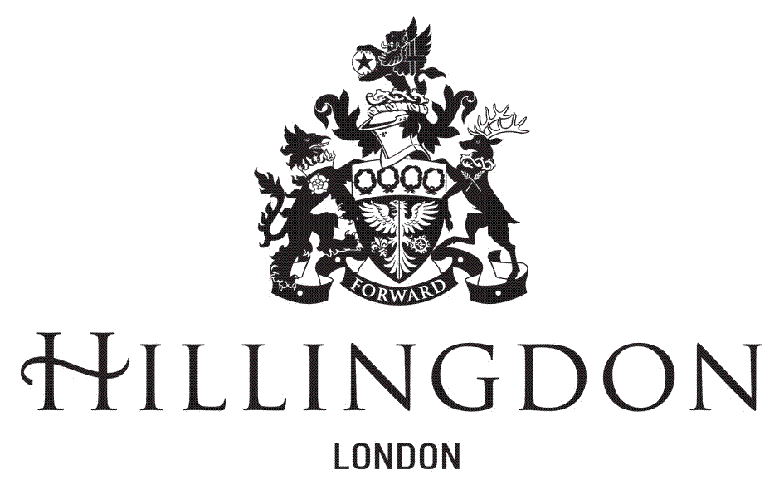 **DIRECT DEBIT**

Make Life Easier

|  |  |
| --- | --- |
| Name: Leasehold  property  address: |  |
|  |
|  |
|  |
|  |
| Post Code: |  |

|  |  |
| --- | --- |
| **Boxes below for use by**  **Residents Services** | |
| Type of account | Service Charge  Major Works |
| Property Ref: |  |
| Person Ref: |  |
| Balance: |  |
| Payments: |  |